Chapter 2
EJB Fundamentals
Chapter 1 introduced the motivation behind EJB. In this chapter, we’ll dive into EJB in detail. After reading this chapter, you will understand the following:
- The different types of enterprise beans.
- What an enterprise bean component is composed of, including the enterprise bean class, the remote interface, the local interface, the EJB object, the local object, the home interface, the home object, the deployment descriptor, and the Ejb-jar file.
- How to write client code to call EJB components.
RMI-IIOP and JNDI
EJB technology is based on two other technologies: Java RMI-IIOP and JNDI. Understanding these technologies is mandatory before continuing.

We have provided you tutorials on each of these technologies in the appendices of this book. If you don’t yet know RMI-IIOP or JNDI, go ahead and read those two appendices now.
Enterprise Beans
An enterprise bean is a server-side software component that can be deployed in a distributed multi-tier environment. An enterprise bean can comprise one or more Java objects because a component may be more than just a simple object. Regardless of an enterprise bean’s composition, the clients of the bean deal with a single exposed component interface. This interface, as well as the enterprise bean itself, must conform to the Enterprise JavaBeans specification. The specification requires that your beans expose a few required methods; these required methods allow the EJB container to manage beans uniformly, regardless of which container your bean is running in.
Note that the “client” of an enterprise bean could be anything--perhaps a servlet, an applet, or even another enterprise bean. In the latter case, a client request to a bean can result in a whole chain of beans being called. This is a very powerful idea because you can subdivide a complex bean task, allowing one bean to call on a variety of prewritten beans to handle the subtasks. This hierarchical concept is quite extensible.
As a real-world example, imagine you go to a music store to purchase a compact disc. The cashier takes your credit card and runs it through a scanner. The scanner has a small Java Virtual Machine running within it, which acts as a client of enterprise beans running on a central server. The central server enterprise beans perform the following tasks:
- Contact American Express, a web service which itself has an EJB-compliant application server containing a number of beans. The beans are responsible for conducting the credit card transaction on behalf of that client.
- Call a product catalog bean, which updates inventory and subtracts the quantity the customer purchased.
- Call an order entry bean, which enters the record for the customer, and returns that record locator back to the scanner to give to the customer on a receipt.
As you can see, this is a powerful, flexible model, which can be extended as needed.
Types of Beans
EJB 2.0 defines three different kinds of enterprise beans:
Session beans. Session beans model business processes. They are verbs because they perform actions. The action could be anything, such as adding numbers, accessing a database, calling a legacy system, or calling other enterprise beans. Examples include a pricing engine, a workflow engine, a catalog engine, a credit card authorizer, or a stock-trading engine.
Entity beans. Entity beans model business data. They are nouns because they are data objects--that is, they are Java objects that cache database information. Examples include a product, an order, an employee, a credit card, or a stock. Session beans typically harness entity beans to achieve business goals, such as a stock-trading engine (session bean) that deals with stocks (entity beans). For more examples of this, see Table 2.1.
Message-driven beans. Message-driven beans are similar to session beans, in that they are verbs that perform actions. The difference is that you can only call message-driven beans by sending messages to those beans (fully described in Chapter X). Examples of message-driven beans include message driven beans that receive stock trade messages, credit card authorization messages, or workflow messages. These message-driven beans might call other enterprise beans as well.
Session Bean | Entity Bean
Bank Teller | Bank Account
Credit Card Authorizer | Credit Card
DNA Sequencer | DNA Strand
Order Entry System | Order, Line Item
Catalog Engine | Product
Auction Broker | Bid, Item
Purchase Order Approval Router | Purchase Order
Table 2.1 Session beans calling entity beans
You may be wondering why the EJB paradigm is so robust in offering the various kinds of beans. Why couldn’t Sun come up with a simpler model? Microsoft’s N-tier vision, for example, does not include the equivalent of entity beans--components that represent data in a permanent storage.
The answer is that Sun is not the only company involved in constructing the Enterprise JavaBeans standard. In fact, many companies have been involved, each with customers that have different kinds of distributed systems. To accommodate the needs of different enterprise applications, Sun decided to allow users the flexibility of each kind of bean.
Admittedly, this increases the ramp-up time to learn EJB. But it also pays off in the long run with increased functionality. By including session beans, Sun has provided a mechanism to model business processes without writing middleware in a distributed multi-tier environment. By including entity beans in the EJB specification, Sun has taken the first steps toward persistent, distributed objects usable by those business processes. And with message-driven beans, you can use messaging to access your EJB system.
See Figure 2.X for a diagram showing the many possibilities of clients interacting with an EJB component system.
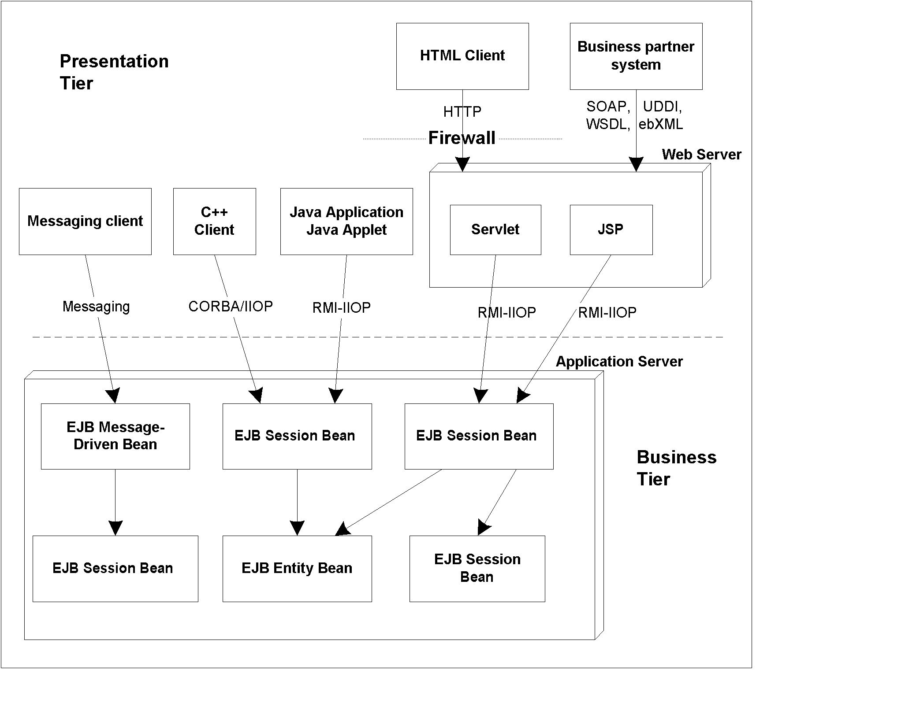Figure 2.X Clients Interacting with an EJB component system.
Distributed Objects: The foundation for EJB
Now that you’ve seen the different types of beans, let’s dive into the technology behind them. EJB components are based on distributed objects. A distributed object is an object that is callable from a remote system. It can be called from an in-process client, an out-of-process client, or a client located elsewhere on the network.
Figure 2.X shows how a client can call a distributed object. Here is an explanation of the diagram:
- The client calls a stub, which is a client-side proxy object. This stub is responsible for masking network communications from the client. The stub knows how to call over the network using sockets, massaging parameters as necessary into their network representation.
- The stub calls over the network to a skeleton, which is a server-side proxy object. The skeleton masks network communication from the distributed object. The skeleton understands how to receive calls on a socket. It also knows how to massage parameters from their network representations to their Java representations.
- The skeleton delegates the call to the distributed object. The distributed object does it’s work, and then returns control back to the skeleton, which returns back to the stub, which then returns control back to the client.
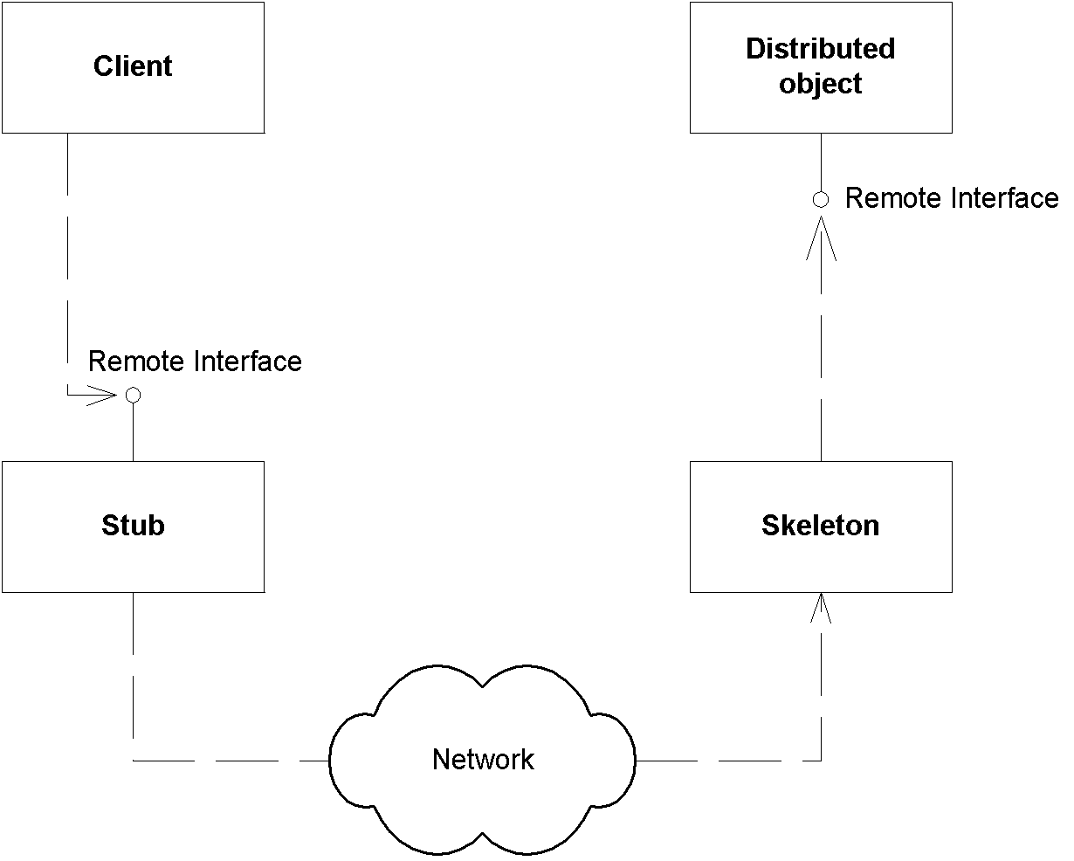Figure 2.X Distributed objects.
A key point here is that both the stub and the distributed object implement the same interface (called the remote interface). This means the stub clones the distributed object’s method signatures. When a client calls a method on the stub, the client thinks he is calling the distributed object directly, when in reality, the client is calling an empty stub that knows how to go over the network. This is called local/remote transparency.
You can achieve distributed objects using many technologies, including the OMG’s CORBA, Microsoft’s DCOM, and Sun’s Java RMI-IIOP (see Appendix X).
Distributed objects and middleware
Distributed objects are great because they allow you to break-up an application across a network. However, as a distributed object application gets larger, you’ll need middleware services to help you, such as transactions and security. There are two ways to get middleware: explicitly and implicitly. Let’s investigate both approaches.
Explicit Middleware
In traditional distributed object programming (such as with traditional CORBA), you could harness middleware by purchasing that middleware off the shelf, and writing code that called that middleware API. For example, you could gain transactions by writing to a transaction API. We call this explicit middleware since you need to write to an API to gain that middleware. This is shown in Figure 2.X
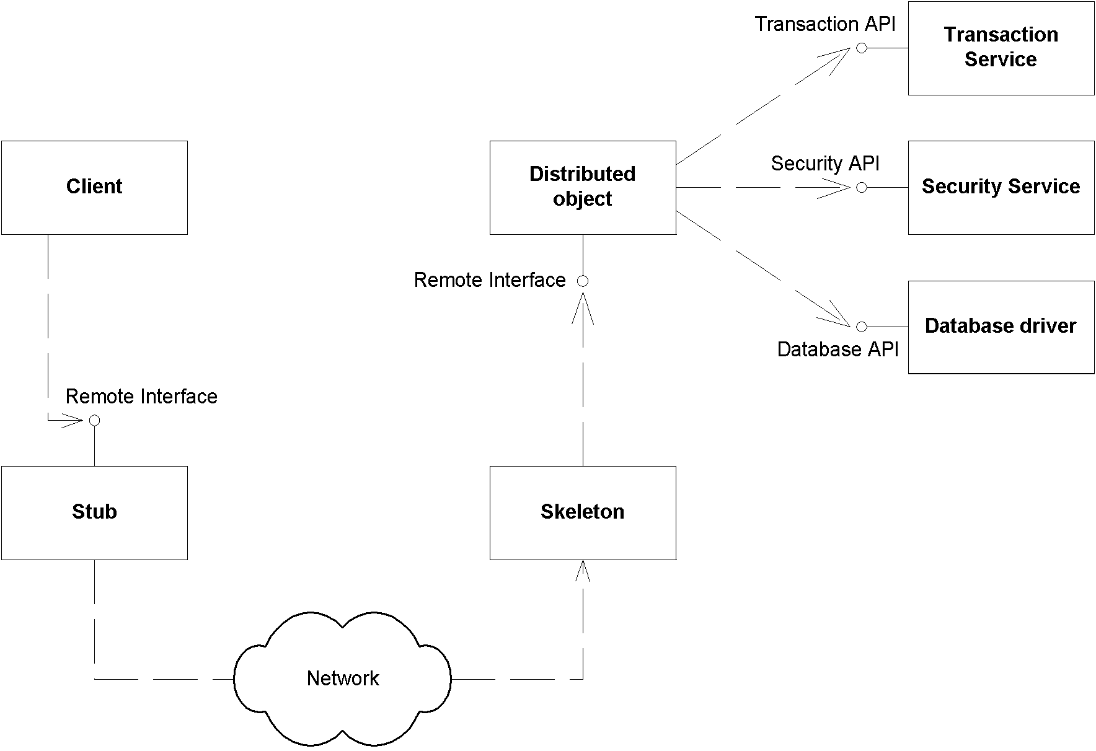Figure 2.X Explicit middleware (gained through APIs).
Here’s a bank account distributed object which knows how to transfer funds from one account to another. It is filled with psuedo-code that illustrates explicit middleware:
transfer(Account account1, Account account2, long amount) {
// 1: Call middleware API to perform a security check
// 2: Call middleware API to start a transaction
// 3: Call middleware API to load rows from the database
// 4: Subtract the balance from one account, add to the other
// 5: Call middleware API to store rows In the database
// 6: Call middleware API to end the transaction
}
As you can see, we are gaining middleware, but our business logic is intertwined with the logic to call these middleware APIs. The downsides to this approach are:
Difficult to write. The code is bloated. We simply want to perform a transfer, and it requires a large amount of code.
Difficult to maintain. If you want to change how you do middleware, you need to rewrite your code.
Difficult to support. If you are an Independent Software Vendor (ISV) selling an application, or an internal department providing code to another department, it is unlikely that you will provide source code to your customers. This is because the source code is your intellectual property, and also because upgrading your customers to the next version of your software is difficult if those customers modify source code. Thus, your customers cannot change their middleware (such as changing how security works).
Implicit Middleware
The crucial, critical difference between systems of the past (transaction processing monitors such as TUXEDO or CICS, or traditional distributed object technologies such as CORBA, DCOM, or RMI) and the newer, component-based technologies (EJB, CORBA Component Model, and Microsoft COM+) is that in this new world, you can harness complex middleware in your enterprise applications without writing to middleware APIs. This is shown in Figure 2.X, and works as follows:
- Write your distributed object to contain only business logic. Do not write to complex middleware APIs. For example, here’s the code that would run inside the distributed object:
transfer(Account account1, Account account2, long amount) {
// 1: Subtract the balance from one account, add to the other
}
- Declare the middleware services that your distributed object needs in a separate descriptor file, such as a plain text file. For example, you might declare that you need transactions, persistence, and a security check.
- Run a command-line tool provided for you by the middleware vendor. This tool takes your descriptor file as input, and generates an object that we’ll call the request interceptor.
- The request interceptor intercepts requests from the client, performs the middleware that your distributed object needs (such as transactions, security, and persistence), and then delegates the call to the distributed object.
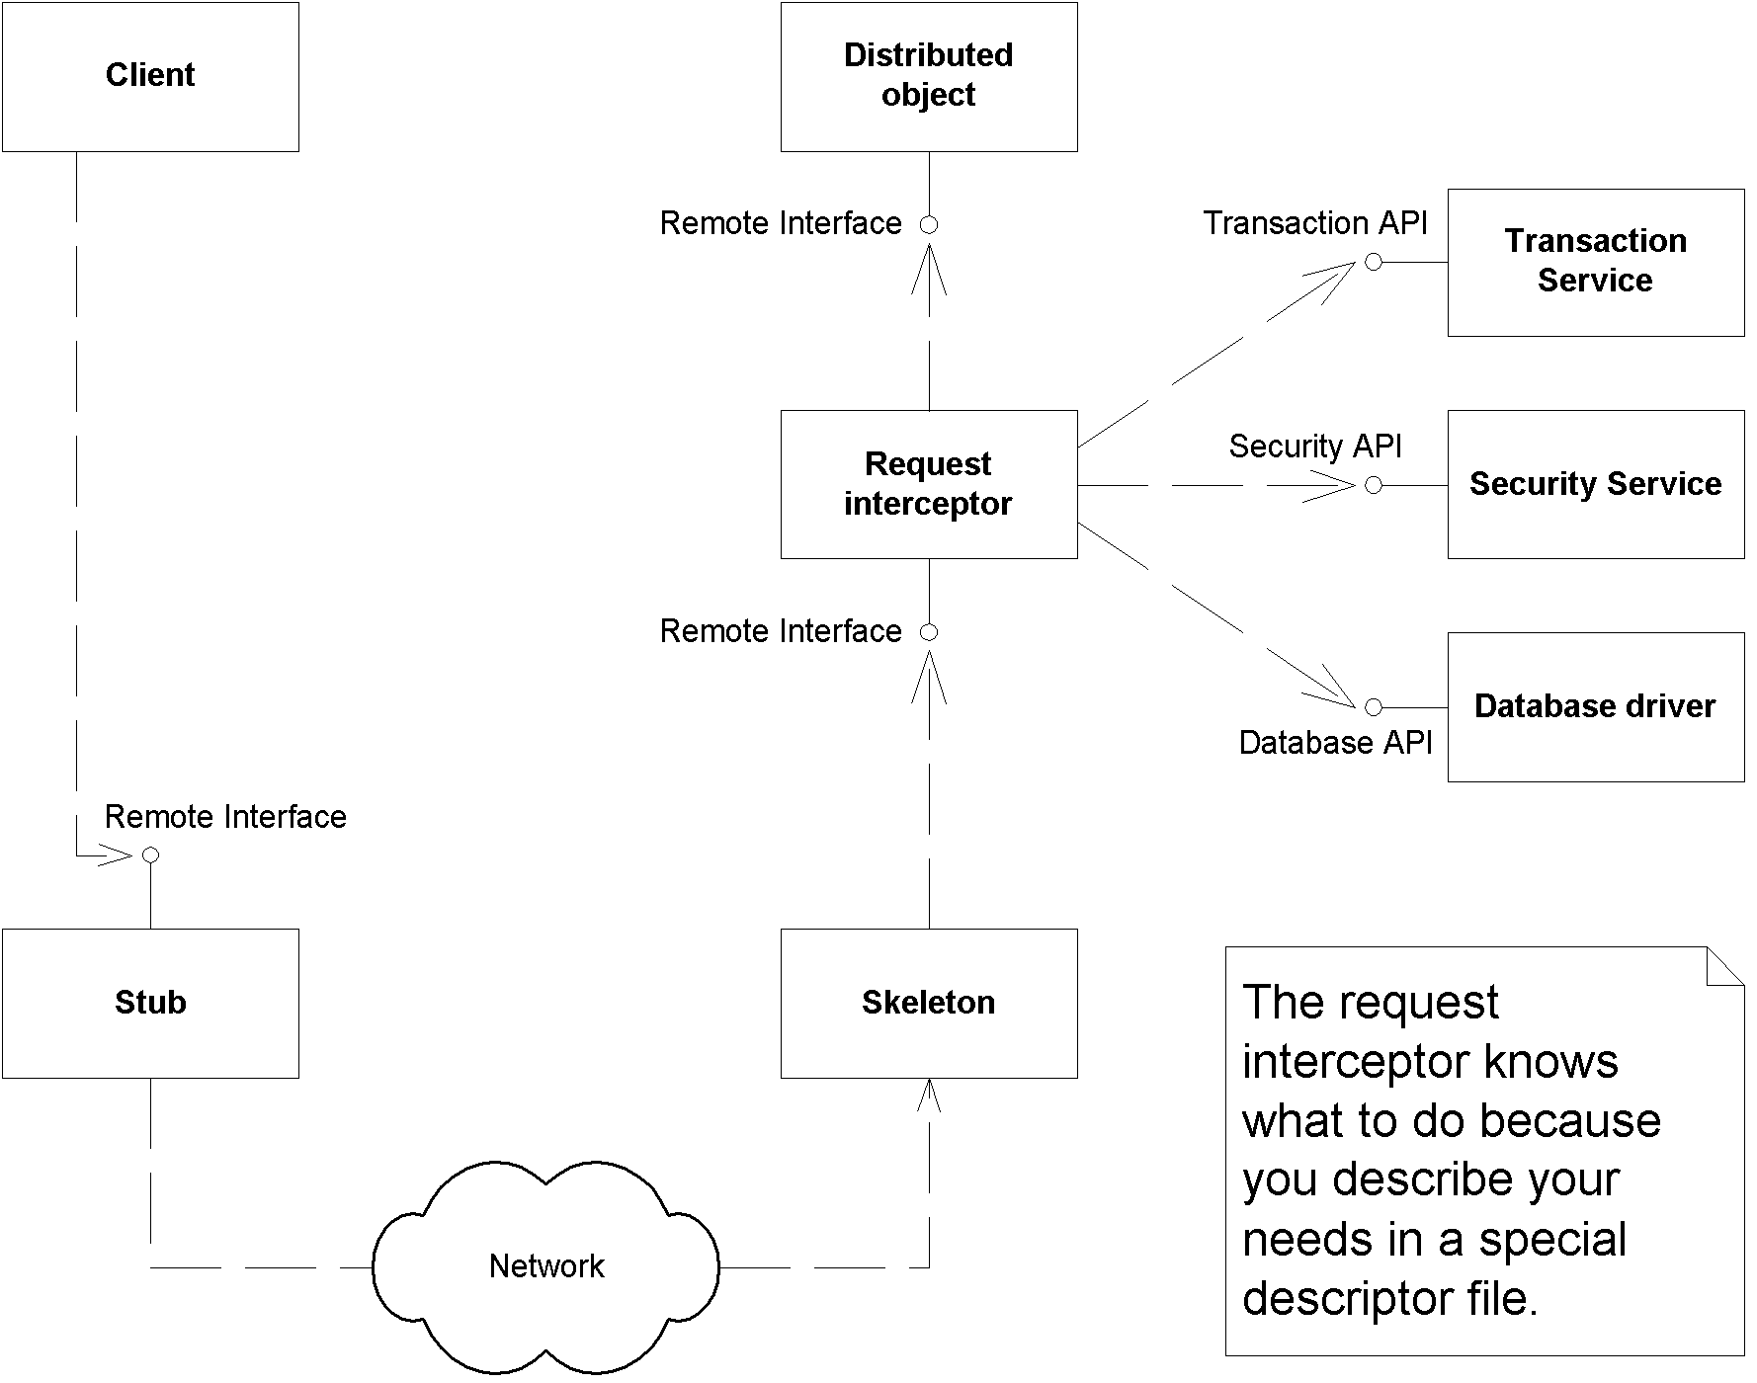Figure 2.X Implicit middleware (Gained through declarations).
The values of implicit middleware (also called declarative middleware) are:
Easy to write. You don’t actually program any code to write to middleware APIs. Rather, you declare what you need in a simple text file. The request interceptor provides the middleware logic for you transparently. You can then focus away from the middleware and concentrate on your application’s business code. This is truly divide-and-conquer!
Easy to maintain. The separation of business logic and middleware logic is clean and maintainable. It is less code, which makes things simpler. Furthermore, changing middleware does not require changing application code.
Easy to support. Customers can change the middleware they need by tweaking the descriptor file. For example, if they need to change how a security check is done, that is doable without modifying source code, avoiding upgrade headaches and intellectual property issues.
What Constitutes an Enterprise Bean?
Now that we understand request interception, we can dive in and see exactly what constitutes an enterprise bean. As we will see, an enterprise bean component is not a single monolothic file--a number of files work together to make up an enterprise bean.
The Enterprise Bean Class
The first part of your bean is the implementation itself, which contains the guts of your logic, called the enterprise bean class. This is simply a Java class that conforms to a well-defined interface and obeys certain rules. The rules are necessary for your beans to run in any EJB container.
An enterprise bean class contains implementation details of your component. And although there are no hard-and-fast rules in EJB, a session bean, entity bean, and message-driven bean implementations will all be very different from each other.
For session beans, an enterprise bean class typically contains business-process-related logic, such as logic to compute prices, transfer funds between bank accounts, or perform order entry.
For entity beans, an enterprise bean class typically contains data-related logic, such as logic to change the name of a customer, reduce the balance of a bank account, or modify a purchase order.
For message-driven beans, an enterprise bean class typically contains message-oriented logic, such as logic to receive a stock trade message and call a session bean that knows how to perform stock trading.
The EJB specification defines a few standard interfaces that your bean class can implement. These interfaces force your bean class to expose certain methods that all beans must provide, as defined by the EJB component model. The EJB container calls these required methods to manage your bean and alert your bean to significant events.
The most basic interface that all bean classes must implement (both session, entity, and message-driven) is the javax.ejb.EnterpriseBean interface, shown in Source 2.1.
public interface javax.ejb.EnterpriseBean extends java.io.Serializable
{
}
Source 2.1 The javax.ejb.EnterpriseBean interface.
This interface serves as a marker interface; implementing this interface indicates that your class is indeed an enterprise bean class. The interesting aspect of javax.ejb.EnterpriseBean is that it extends java.io.Serializable. This means that all enterprise beans can be converted to a bit-blob and share all the properties of serializable objects (described in Appendix X). This will become important later, so keep it in mind.
Session beans, entity beans, and message-driven beans each have more specific interfaces that extend the javax.ejb.EnterpriseBean interface. All session beans must implement javax.ejb.SessionBean, while all entity beans must implement javax.ejb.EntityBean, and all message-driven beans must implement javax.ejb.MessageDrivenBean. We’ll see the details of these interfaces a bit later. For now, know that your enterprise bean class never needs to implement the javax.ejb.EnterpriseBean interface directly--rather, your bean class implements the interface corresponding to its bean type.
The EJB Object
When a client wants to use an instance of an enterprise bean class, the client never invokes the method directly on an actual bean instance. Rather, the invocation is intercepted by the EJB container and then delegated to the bean instance. This is the concept of request interception that we touched on earlier. By intercepting requests, the EJB container can automatically perform implicit middleware. As a component developer, this means your life is simplified greatly because you can rapidly develop components without writing, debugging, or maintaining code that calls middleware APIs. Here are just some of the services that you get at the point of interception:
Implicit distributed transaction management. Transactions allow for you to perform robust, deterministic operations in a distributed environment by setting attributes on your enterprise beans. We’ll get into the details of transactions and how you can use them effectively in Chapter X. For now, know that the EJB container provides a transaction service--a low-level implementation of transaction management and coordination. The transaction service must be exposed through the Java Transaction API (JTA). The JTA is a high-level interface that you can use to control transactions, which we also cover in Chapter X.
Implicit security. Security is a major consideration for multi-tier deployments. The Java 2 Platform, Standard Edition yields a robust security service that can authorize and authenticate users, securing deployments from unwanted visitors. EJB adds to this the notion of transparent security, allowing components to reap the benefits of a secure deployment without necessarily coding to a security API.
Implicit resource management and component life cycle. The EJB container implicitly manages resources for your enterprise beans, such as threads, sockets, and database connections. The life cycle of the enterprise beans themselves are also managed, allowing for the enterprise bean instances to be reused by the EJB container as necessary.
Implicit persistence. Persistence is a natural requirement of any deployment that requires permanent storage. EJB offers assistance here by automatically saving persistent object data to an underlying storage and retrieving that data at a later time.
Implicit remote accessibility. Your enterprise bean class can’t be called across the network directly because an enterprise bean class is not network-enabled. Your EJB container handles networking for you by wrapping your bean in a network-enabled object. The network-enabled object receives calls from clients and delegates these calls to instances of your bean class. This saves you from having to worry about networking issues (the container provides networking as a free service to you). EJB products thus automatically convert your stand-alone, network-less components into distributed, network-aware beings.
Implicit multiclient support. EJB containers automatically handle concurrent requests from clients. EJB containers provide built-in thread support, instantiating multiple copies of your component as necessary by instantiating lots of instances of your enterprise bean, and pushing one thread through each instance. This way, you don’t need to worry about writing thread-safe enterprise bean code.
Implicit component location transparency. Clients of components are decoupled from the specific whereabouts of the component being used.
Implicit monitoring. The EJB container can track which methods are invoked, display a real-time usage graph on a system administrator’s user interface, gather data for intelligent load balancing, and more. There is no requirement that an EJB container perform these tasks; however, high-end EJB containers will perform these tasks at the point of interception.
Thus, the EJB container is acting as a layer of indirection between the client code and the bean. This layer of indirection manifests itself as a single network-aware object, called the EJB object.
Fun Fact
A layer of indirection solves every problem in Computer Science.
The EJB object is a surrogate object that knows about networking, transactions, security, and more. It is an intelligent object that knows how to perform intermediate logic that the EJB container requires before a method call is serviced by a bean class instance. An EJB object is the request interceptor, or the glue, between the client and the bean. EJB objects replicate and expose every business method that the bean itself exposes. EJB objects delegate all client requests to beans. We depict EJB objects in Figure 2.X.
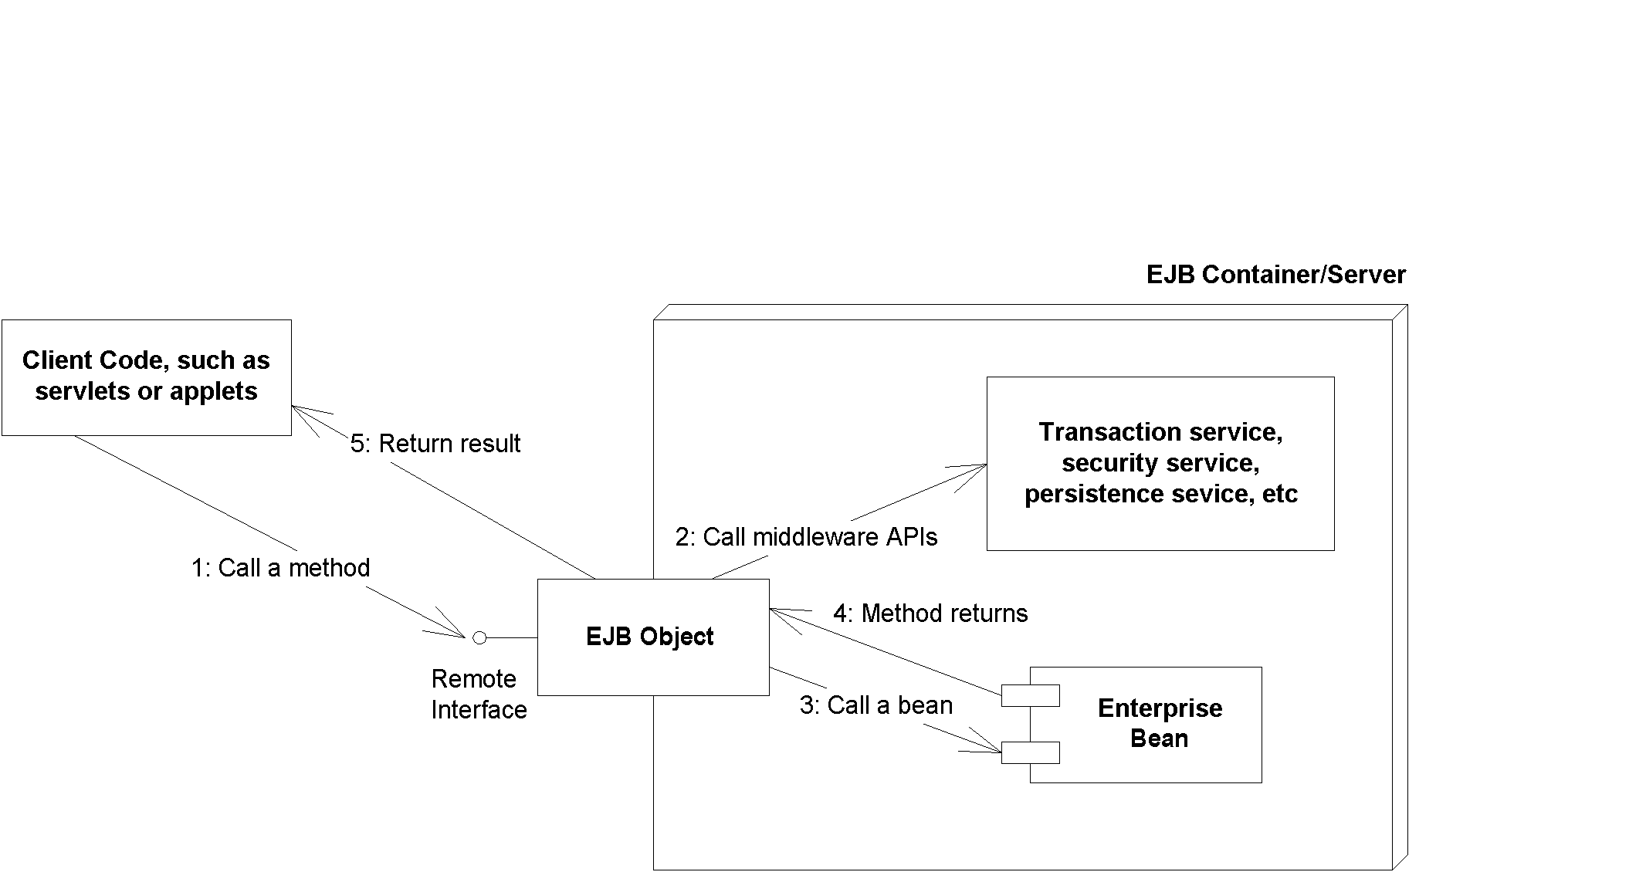Figure 2.X EJB objects.
You should think of EJB objects as physical parts of the container; all EJB objects have container-specific code inside of them (each container handles middleware differently and provides different qualities of service). Because each bean’s EJB object is different, your container vendor generates the class file for your EJB objects automatically.
Each EJB container ships with a suite of glue-code tools. These tools are meant to integrate beans into the EJB container’s environment. The tools generate helper Java code, such as stubs, skeletons, data access classes, and other classes that this specific container requires. Bean providers do not have to think about the specifics of how each EJB container works because the container’s tools generate its own proprietary Java code automatically.
The container’s glue-code tools are responsible for transforming an enterprise bean into a fully managed, distributed server-side component. This involves logic to handle resource management, life cycle, state management, transactions, security, persistence, and remote accessibility, and many other services (see Chapter X). The automatic code generated handles these services in the container’s proprietary way.
The EJB container: Your silent partner
EJB containers are responsible for managing your beans. Containers can interact with your beans by calling your beans’ required management methods as necessary. These management methods are your bean’s callback methods that the container, and only the container, invokes. The management methods allow the container to alert your bean when middleware events take place, such as when an entity bean is about to be persisted to storage.

The most important responsibility of an EJB container is to provide an environment in which enterprise beans can run. EJB containers house the enterprise beans and make them available for clients to invoke remotely. In essence, EJB containers act as invisible middlemen between the client and the beans. They are responsible for connecting clients to beans, performing transaction coordination, providing persistence, managing a bean’s life cycle, and other tasks.

The key to understanding EJB containers is to realize that they are abstract entities. Neither the beans nor the clients that call beans ever explicitly code to the API of an EJB container. Rather, the container implicitly manages the overhead of a distributed component architecture. The container is analogous to a ‘behind the scenes’ stage manager in a theatre, providing the lighting and backdrop necessary for a successful stage performance by the actors on stage. But neither the actors nor the audience directly interact with the stage manager. The same is true for EJB containers. Neither the beans nor the clients that call the beans ever code directly to an EJB container API.
The Remote Interface
As we mentioned previously, bean clients invoke methods on EJB objects, rather than the beans themselves. To perform this, EJB objects must clone every business method that your bean classes expose. But how do the tools that auto-generate EJB objects know which methods to clone? The answer is in a special interface that a bean provider writes. This interface duplicates all the business logic methods that the corresponding bean class exposes. This interface is called the remote interface.
Remote interfaces must comply with special rules that the EJB specification defines. For example, all remote interfaces must derive from a common interface that is supplied by Sun Microsystems. This interface is called javax.ejb.EJBObject, and it is shown in Source 2.2.
public interface javax.ejb.EJBObject
extends java.rmi.Remote
{
public abstract javax.ejb.EJBHome getEJBHome()
throws java.rmi.RemoteException;

public abstract java.lang.Object getPrimaryKey()
throws java.rmi.RemoteException;

public abstract void remove()
throws java.rmi.RemoteException,
javax.ejb.RemoveException;

public abstract javax.ejb.Handle getHandle()
throws java.rmi.RemoteException;

public abstract boolean isIdentical(javax.ejb.EJBObject)
throws java.rmi.RemoteException;
}
Source 2.2 A preview of the javax.ejb.EJBObject interface.
javax.ejb.EJBObject lists a number of interesting methods. For now, don’t worry about fully understanding the meanings--just know that these methods are required methods that all EJB objects must implement. And remember that you don’t implement the methods--the EJB container does when it auto-generates the EJB objects for you.
The client code that wants to work with your beans calls the methods in javax.ejb.EJBObject. This client code could be stand-alone applications, applets, servlets, or anything at all--even other enterprise beans.
In addition to the methods listed in Table 2.2, your remote interface duplicates your beans’ business methods. When a bean’s client invokes any of these business methods, the EJB object will delegate the method to its corresponding implementation--which resides in the bean itself.
Java RMI-IIOP and EJB Objects
You may have noticed that javax.ejb.EJBObject extends java.rmi.Remote. The java.rmi.Remote interface is part of Java Remote Method Invocation over the Internet Inter-ORB Protocol (RMI-IIOP). Any object that implements java.rmi.Remote is a remote object and is callable from a different Java Virtual Machine. This is how remote method invocations are performed in Java (we fully describe this in Appendix X).
Because the EJB object--provided by the container--implements your remote interface, it also indirectly implements java.rmi.Remote as well. This means that your EJB objects are fully networked objects, able to be called from other Java Virtual Machines or physical machines located elsewhere on the network. Thus, EJB remote interfaces are really just RMI-IIOP remote interfaces--with the exception that EJB remote interfaces must also be built to conform to the EJB specification.
EJB remote interfaces must conform to RMI-IIOP’s remote interface rules. For example, any method that’s part of a remote object callable across virtual machines must throw a special remote exception. A remote exception is a java.rmi.RemoteException, or also (technically) a superclass of it. A remote exception indicates that something unexpected happened on the network while you were invoking across virtual machines, such as a network, process, or machine failure. Every method shown in Table 2.2 for javax.ejb.EJBObject throws a java.rmi.RemoteException.
Remote interfaces must conform to RMI-IIOP’s parameter-passing conventions as well. Not everything can be passed over the network in a cross-VM method call. The parameters you pass in methods must be valid types for RMI-IIOP. This includes primitives, serializable objects, and RMI-IIOP remote objects. The full details of what you can pass are given in Appendix X.
Location Transparency
EJB inherits a very significant benefit from RMI-IIOP. In RMI-IIOP, the physical location of the remote object you’re invoking on is masked from you. This feature spills over to EJB. Your client code is unaware of whether the EJB object it’s using is located on a machine next door or a machine across the Internet. It also means the EJB object could be located on the same Java VM as the client. This is called location transparency.

Why is location transparency beneficial? Well, for one thing, you aren’t writing your bean’s client code to take advantage of a particular deployment configuration because you’re not hard-coding machine locations. This is an essential part of reusable components that can be deployed in a wide variety of multi-tier situations.

Location transparency also enables container vendors to provide additional value-adds, such as the ability to take a machine on the network down temporarily to perform system maintenance, to install new software, or to upgrade the components on that machine. During maintenance, location transparency allows for another machine on the network to serve up components for a component’s client because that client is not dependent on the hard locations of any components. If a machine that has components on it crashes due to hardware or software error, you may be able to reroute client invocations to other machines without the client even knowing about the crash, allowing for an enhanced level of fault-tolerance.
The Local Interface
One problem with the remote interface is that calling beans through that interface is very slow, and you will incur a great deal of overhead and expense. Just to give you an idea of what happens when you call a bean, the following steps may occur:
- The client calls a local stub.
- The stub marshals parameters into a form suitable for the network.
- The stub goes over a network connection to the skeleton.
- The skeleton demarshals parameters into a form suitable for Java.
- The skeleton calls the EJB object.
- The EJB object performs needed middleware, such as connection pooling, transactions, security, and life-cycle services.
- Once the enterprise bean instance does it’s work, each of the above steps then must be repeated for the return trip back home.
Ouch! That’s a lot of overhead. Figure 2.X shows this process.
New to EJB 2.0, you can now call enterprise beans in a fast, efficient way by calling them through their local objects rather than EJB objects. Local objects implement a local interface rather than a remote interface. The local objects are speed-demons that allow you to make high-performing enterprise beans. The process works as follows:
- The client calls a local object.
- The local object performs needed middleware, such as connection pooling, transactions, security, and life-cycle services.
- Once the enterprise bean instance does its work, each of the above steps then must be repeated for the return trip back home.
As you can see, we are avoiding the steps of the stub, the skeleton, the network, and the marshaling/demarshaling of parameters. This empowers us to write smaller beans that perform more fine-grained tasks.
Drawbacks of the local interface
The local interface only works when you’re calling beans in the same process. For example, if you have a bank teller session bean that calls a bank account entity bean in the same application server. But there lies the rub. You cannot call a bean remotely if your code relies on the local interface. If you decide to switch between a local or remote call, you must change your code from using the local interface to using the remote interface.
For the remainder of this book, we will use the word EJB object to mean the request interceptor, and the remote interface to mean the interface to the request interceptor. Unless it’s pointed out explicitly, all information that applies to an EJB object also applies to a local object, and all information that applies to a remote interface also applies to a local interface.
Remote Interfaces and Message-Driven Beans
You call a message-driven bean by sending messages to it. You do not call it through method signatures in a remote interface. Therefore, message-driven beans do not have remote interfaces. We explain this in more detail in Chapter X.
The Home Object
As we’ve seen, client code deals with EJB objects and never with beans directly. The next logical question is, how do clients acquire references to EJB objects?
The client cannot instantiate an EJB object directly because the EJB object could exist on a different machine than the one the client is on. Similarly, EJB promotes location transparency, so clients should never be aware of exactly where an EJB object resides.
To acquire a reference to an EJB object, your client code asks for an EJB object from an EJB object factory. This factory is responsible for instantiating (and destroying) EJB objects. The EJB specification calls such a factory a home object. The chief responsibilities of home objects are to do the following:
- Create EJB objects
- Find existing EJB objects (for entity beans--we’ll learn about that in Chapter X)
- Remove EJB objects
Just like EJB objects, home objects are proprietary and specific to each EJB container. They contain interesting container-specific logic, such as load-balancing logic, logic to track information on a graphical administrative console, and more. And just like EJB objects, home objects are physically part of the container and are auto-generated by the container vendor’s tools.
The Home Interface
We’ve seen that home objects are factories for EJB objects. But how does a home object know how you’d like your EJB object to be initialized? For example, one EJB object might expose an initialization method that takes an integer as a parameter, while another EJB object might take a String instead. The container needs to know this information to generate home objects. You provide this information to the container by specifying a home interface. Home interfaces simply define methods for creating, destroying, and finding EJB objects. The container’s home object implements your home interface. We show this in Figure 2.X.
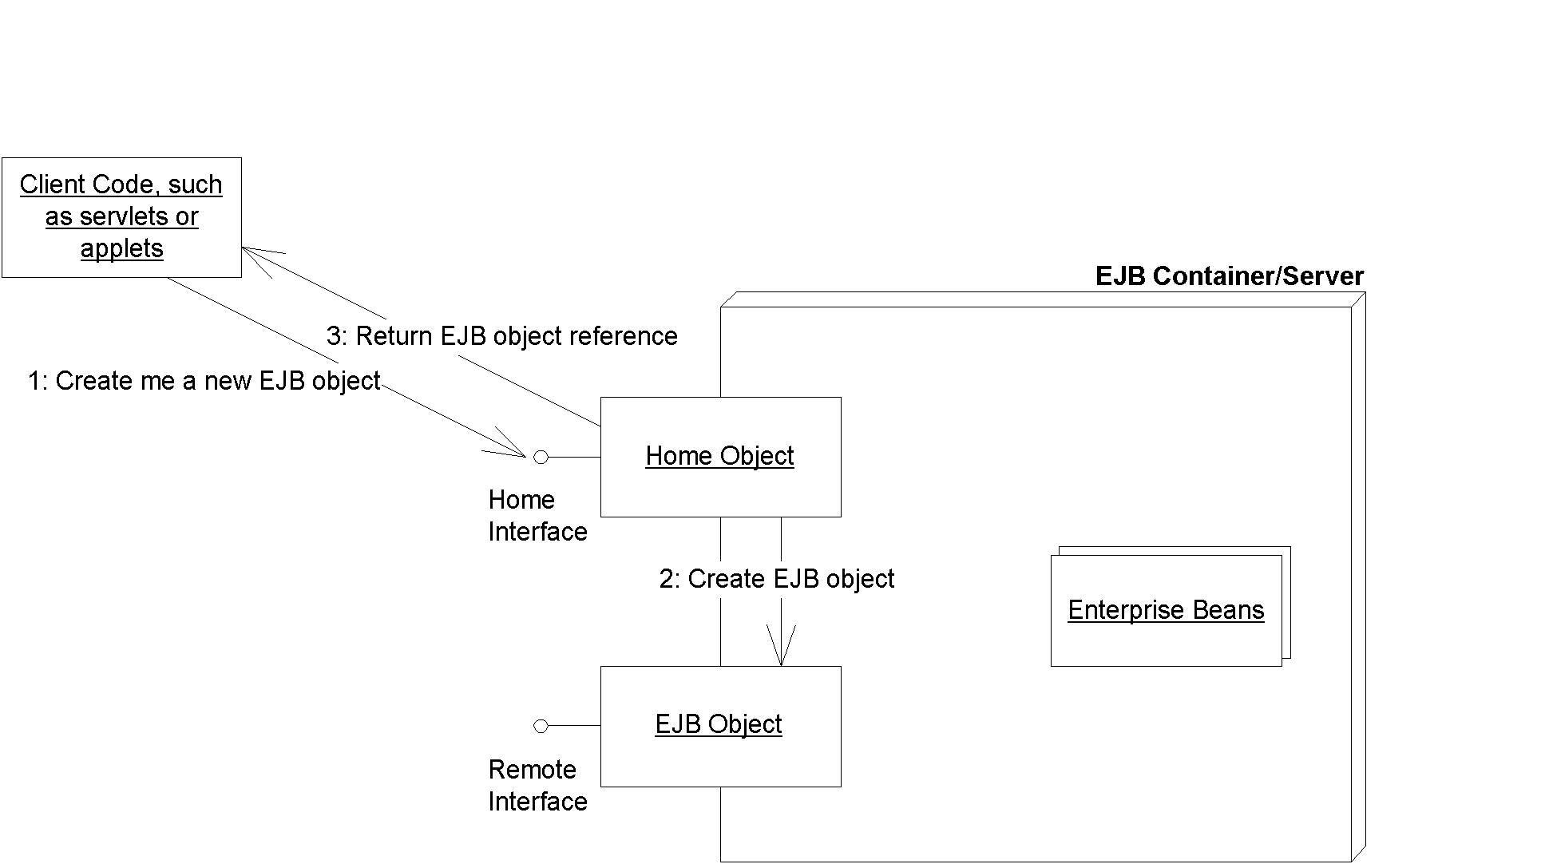Figure 2.X Home interfaces and objects.
As usual, EJB defines some required methods that all home interfaces must support. These required methods are defined in the javax.ejb.EJBHome interface--an interface that your home interfaces must extend. We show javax.ejb.EJBHome in Source 2.2. We will learn about these methods later.
public interface javax.ejb.EJBHome extends java.rmi.Remote
{
public EJBMetaData getEJBMetaData()
throws java.rmi.RemoteException;

public javax.ejb.HomeHandle getHomeHandle()
throws java.rmi.RemoteException;

public void remove(Handle handle)
throws java.rmi.RemoteException
javax.ejb.RemoveException;

public void remove(Object primaryKey)
throws java.rmi.RemoteException,
javax.ejb.RemoveException;
}
Source 2.3 A preview of the javax.ejb.EJBHome interface.
Notice that the parent javax.ejb.EJBHome derives from java.rmi.Remote. This means your home interfaces do as well, implying that home objects are also fully networked Java RMI remote objects, which can be called across VMs. The types of the parameters passed in the home interface’s methods must be valid types for Java RMI.
Deployment Descriptors
To inform the container about your middleware needs, you as a bean provider must declare your components’ middleware service requirements in a deployment descriptor file. For example, you can use a deployment descriptor to declare how the container should perform life-cycle management, persistence, transaction control, and security services. The container inspects the deployment descriptor and fulfills the requirements that you lay out. The deployment descriptor is the key to implicit middleware.
For example, you can use a deployment descriptor to specify the following requirements of your bean:
Bean management and life-cycle requirements. These deployment descriptor settings indicate how the container should manage your beans. For example, you specify the name of the bean’s class, whether the bean is a session, entity, or message-driven bean, and the home interface that generates the beans.
Persistence requirements (entity beans only). Authors of entity beans use the deployment descriptors to inform the container about whether the bean handles its persistence on its own or lets the delegates the persistence to the EJB container in which it’s deployed.
Transaction requirements. You can also specify transaction settings for beans in deployment descriptors. These settings control what the bean requirements are for running in a transaction, such as “A transaction must start whenever anyone calls this bean, and the transaction must end after my bean completes the method call.”
Security requirements. Deployment descriptors contain access control entries, which the beans and container use to control access control to certain operations. For example, you can specify who is allowed to use which beans, and even who is allowed to use each method on a particular bean. You can also specify what security roles the beans themselves should run in, which is useful if the beans need to perform secure operations. For example, “Only bank executives can call the method to create new bank accounts.”
In EJB 2.0, a deployment descriptor is an XML file. You can write these XML files by hand, or (if you’re lucky) your Integrated Development Environment (IDE) or EJB container will supply tools to generate the XML deployment descriptor. For example, you might simply need to step through a wizard in a Java IDE to generate a deployment descriptor.
As a bean provider, you are responsible for creating a deployment descriptor. Once your bean is used, other parties can modify its deployment descriptor settings. For example, when an application assembler is piecing together an application from beans, he or she can tune your deployment descriptor. Similarly, when a deployer is installing your beans in a container in preparation for a deployment to go live, he or she can tune your deployment descriptor settings as well. This is all possible because deployment descriptors declare how your beans should use middleware, rather than your writing code that uses middleware. Declaring rather than programming enables people without Java knowledge to tweak your components at a later time. This paradigm becomes an absolute necessity when purchasing EJB components from a third party because third-party source code is typically not available. By having a separate customizable deployment descriptor, you can very easily fine-tune components to a specific deployment environment without changing source code.
Vendor-specific files
Since all EJB server vendors are different, they each have some proprietary value-added features. The EJB specification does not touch these features, such as how to configure load-balancing, clustering, monitoring, and so-on.
Because of this, each EJB server vendor may require that you include additional files that are specific to that vendor, such as XML files, text files, or binary files.
Ejb-jar File
Once you’ve generated your bean classes, your home interfaces, your remote interfaces, your deployment descriptors, and your bean’s properties, it’s time to package them up into one entity. This entity is called the Ejb-jar file. It is a compressed file that contains everything we have described, and it follows the .ZIP compression format. Jar files are convenient, compact modules for shipping your Java software. The Ejb-jar file creation process is shown in Figure 2.X.
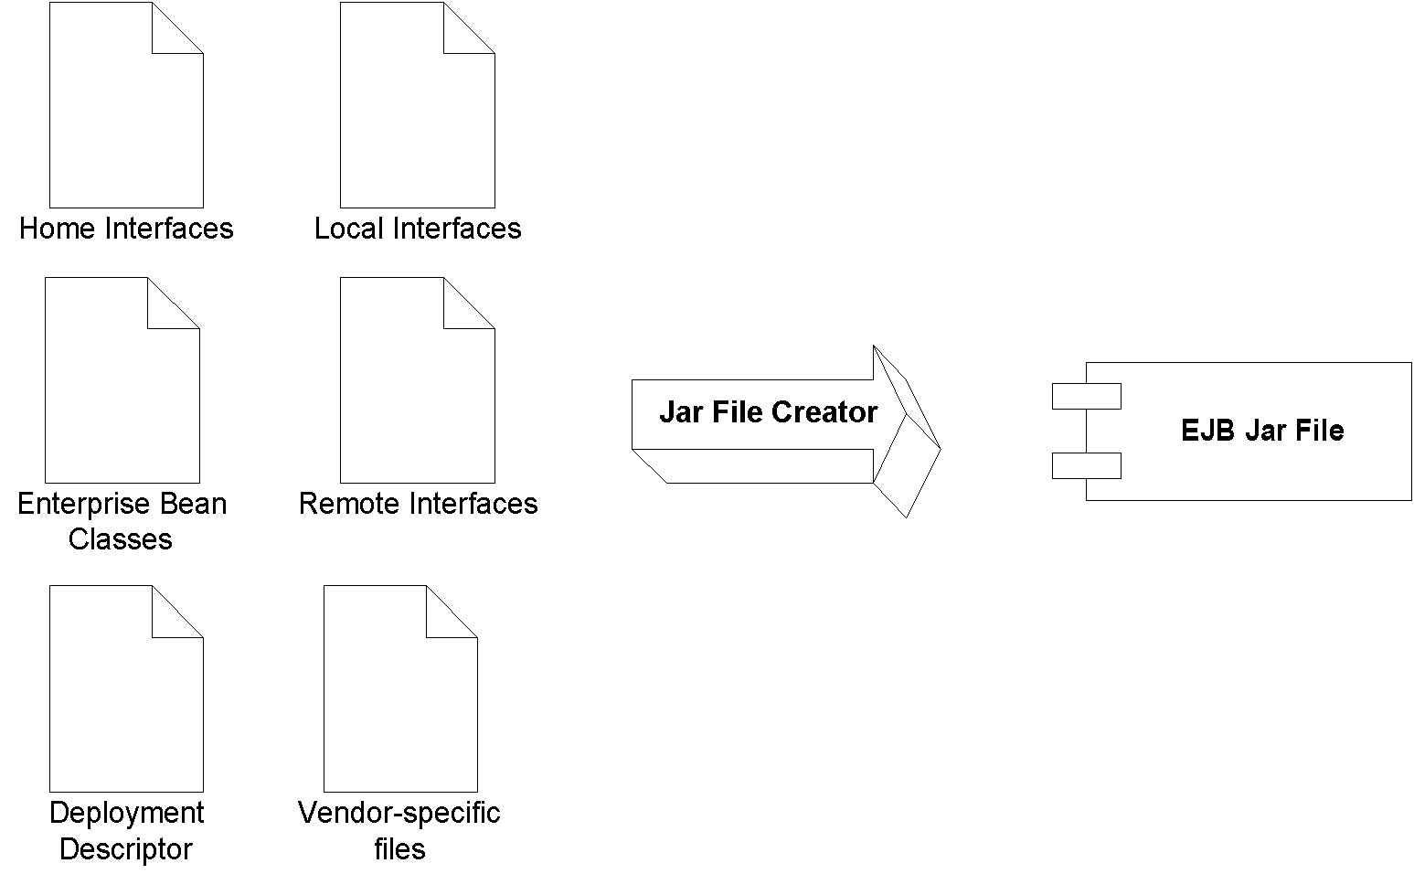Figure 2.X Creating an Ejb-jar file.
There are already a number of tools available to auto-generate Ejb-jar files, such as Java IDEs. You can also generate these files yourself--we’ll show you how in Chapter X.
Once you’ve made your Ejb-jar file, your enterprise bean is complete, and it is a deployable unit within an application server. When they are deployed (perhaps after being purchased), the tools that EJB container vendors supply are responsible for decompressing and reading and extracting the information contained within the Ejb-jar file. From there, the deployer has to perform vendor-specific tasks, such as generating EJB objects, generating home objects, importing your bean into the container, and tuning the bean. Support for Ejb-jar files is a standard, required feature that all EJB tools support.
Summary of Terms
For your convenience, we now list the definitions of each term we’ve described so far. As you read future chapters, refer back to these definitions whenever you need clarification (you may want to bookmark this page).
The enterprise bean instance is a Java object instance of an enterprise bean class. It contains business method implementations of the methods defined in the remote interface. The enterprise bean instance is “network-less” in that it contains no networked logic.
The remote interface is a Java interface that enumerates the business methods exposed by the enterprise bean class. In EJB, client code always goes through the remote interface and never interacts with the enterprise bean instance. The remote interface is “network-aware” in that the interface obeys the rules for Java RMI-IIOP.
The local interface is the high-performing version of the remote interface. Use the local interface when you are calling enterprise beans that live in the same process. Your calls will not undergo stubs, skeletons, network calls, nor marshaling/demarshaling of parameters.
The EJB object is the container-generated implementation of the remote interface. The EJB object is a network-aware intermediary between the client and the bean instance, handling necessary middleware issues. All client invocations go through the EJB object. The EJB object delegates calls to enterprise bean instances. The EJB object implements the remote interface.
The local object is the high-performing version of the EJB object. The local object implements the local interface.
The home interface is a Java interface that serves as a factory for EJB objects. Client code that wants to work with EJB objects must use the home interface to generate them. The home interface is network-aware because clients use it across the network.
The home object is the container-generated implementation of the home interface. The home object is also network-aware, and it obeys RMI-IIOP’s rules.
The deployment descriptor is an XML file which specifies the middleware requirements of your bean. You use the deployment descriptor to inform the container about the implicit middleware you want, such as how to manage your bean, your bean’s life-cycle needs, your transactional needs, your persistence needs, and your security needs.
The vendor-specific files allow you to take advantage of vendor-specific features. These files are not portable between application servers.
The Ejb-jar file is the finished, complete ZIPfile that contains the above files. It is the unit of deployment and is given to the application server. The application server unpacks the Ejb-jar file and loads up the bean.
Understanding How to Call Beans
We now take a look at the other half of the world--the client side. We are now customers of the beans’ business logic, and we are trying to solve some real-world problem by using one or more beans together. There are two different kinds of clients:
Java RMI-IIOP based clients. These clients use the Java Naming and Directory Interface (JNDI) to look up objects over a network, and they use the Java Transaction API (JTA) to control transactions.
CORBA clients. Clients can also be written to the CORBA standard. This would primarily be useful if you want to call your EJB components using another language, such as C++. CORBA clients use the CORBA Naming Service (COS Naming) to look up objects over the network, and they use the CORBA’s Object Transaction Service (OTS) to control transactions.
Whether you’re using CORBA or RMI-IIOP, your client code typically looks like this:
- Look up a home object.
- Use the home object to create an EJB object.
- Call business methods on the EJB object.
- Remove the EJB object.
Let’s go through each of these steps with RMI-IIOP based clients. See Chapter X for CORBA.
Looking Up a Home Object
To look up a home object, your client code must use the JNDI. We now provide a brief overview of the role JNDI plays in deployments; feel free to read Appendix X for the full details of how JNDI works.
The Role of Naming and Directory Services in EJB
One of the goals of EJB is that your application code should be “write once, run anywhere.” If you deploy a bean onto one machine and then switch that for a different machine, your code should not change, because your code is location transparent.
EJB achieves location transparency by leveraging naming and directory services. Naming and directory services are products that store and look up resources across a network. Some examples of directory service products are the iPlanet Directory Server, Microsoft’s Active Directory, and IBM’s Lotus Notes.
Traditionally, corporations have used directory services to store usernames, passwords, machine locations, printer locations, and so on. EJB servers exploit directory services to store location information for resources that your application code uses in an enterprise deployment. These resources could be EJB home objects, enterprise bean environment properties, database drivers, message service drivers, and other resources. By using directory services, you can write application code that does not depend on specific machine names or locations. This is all part of EJB’s location transparency, and it keeps your code portable. If later you decide that resources should be located elsewhere, your code will not need to be rebuilt because the directory service can simply be updated to reflect the new resource locations. This greatly enhances maintenance of a multi-tier deployment that may evolve over time. This becomes absolutely necessary when purchasing prewritten software (such as enterprise beans), because your purchased components’ source code will likely not be made available to you to change.
Where does the naming and directory service exist?
While naming and directory servers have typically run standalone, they can also run in the same process as the application server. For example, with BEA WebLogic, the application server itself is written in Java, and so the naming and directory service is just a bunch of Java classes that run inside of BEA WebLogic.
Unless you’re using CORBA, the de facto API used to access naming and directory services is JNDI. JNDI adds value to your enterprise deployments by providing a standard interface for locating users, machines, networks, objects, and services. For example, you can use the JNDI to locate a printer on your corporate intranet. You can also use it to locate a Java object or to connect with a database. In EJB, JNDI is used extensively for locating resources across an enterprise deployment, including home objects, environment properties, database resources, and more.
There are two common steps that must be taken to find any resource in an EJB deployment:
- Associate the resource with a “nickname” in your deployment descriptor. Your EJB server will bind the nickname to the resource.
- Clients of the resource can use the nickname with JNDI to look up the resource across a deployment.
How to Use JNDI to Locate Home Objects
To achieve location transparency, EJB containers mask the specific locations of home objects from your enterprise beans’ client code. Clients do not hard-code the machine names that home objects reside on, but rather they use JNDI to look up home objects. Home objects are physically located “somewhere” on the network--perhaps in the address space of an EJB container, perhaps in the address space of the client, or perhaps elsewhere on the network. As a developer who writes client code to use beans, you don’t care.
For clients to locate a home object, you must provide a nickname for your bean’s home object. Clients will use this nickname to identify the home object it wants. For example, if you have a bean called MyBean, you may specify a nickname MyHome in the deployment descriptor. The container will automatically bind the nickname MyHome to the home object. Then any client on any machine across a multi-tier deployment can use that nickname to find home objects, without regard to physical machine locations. Clients use the JNDI API to do this. JNDI goes over the network to some directory service to look for the home object, perhaps contacting one or more directory services in the process. Eventually the home object is found, and a reference to it is returned to the client. This is shown in Figure 2.X.
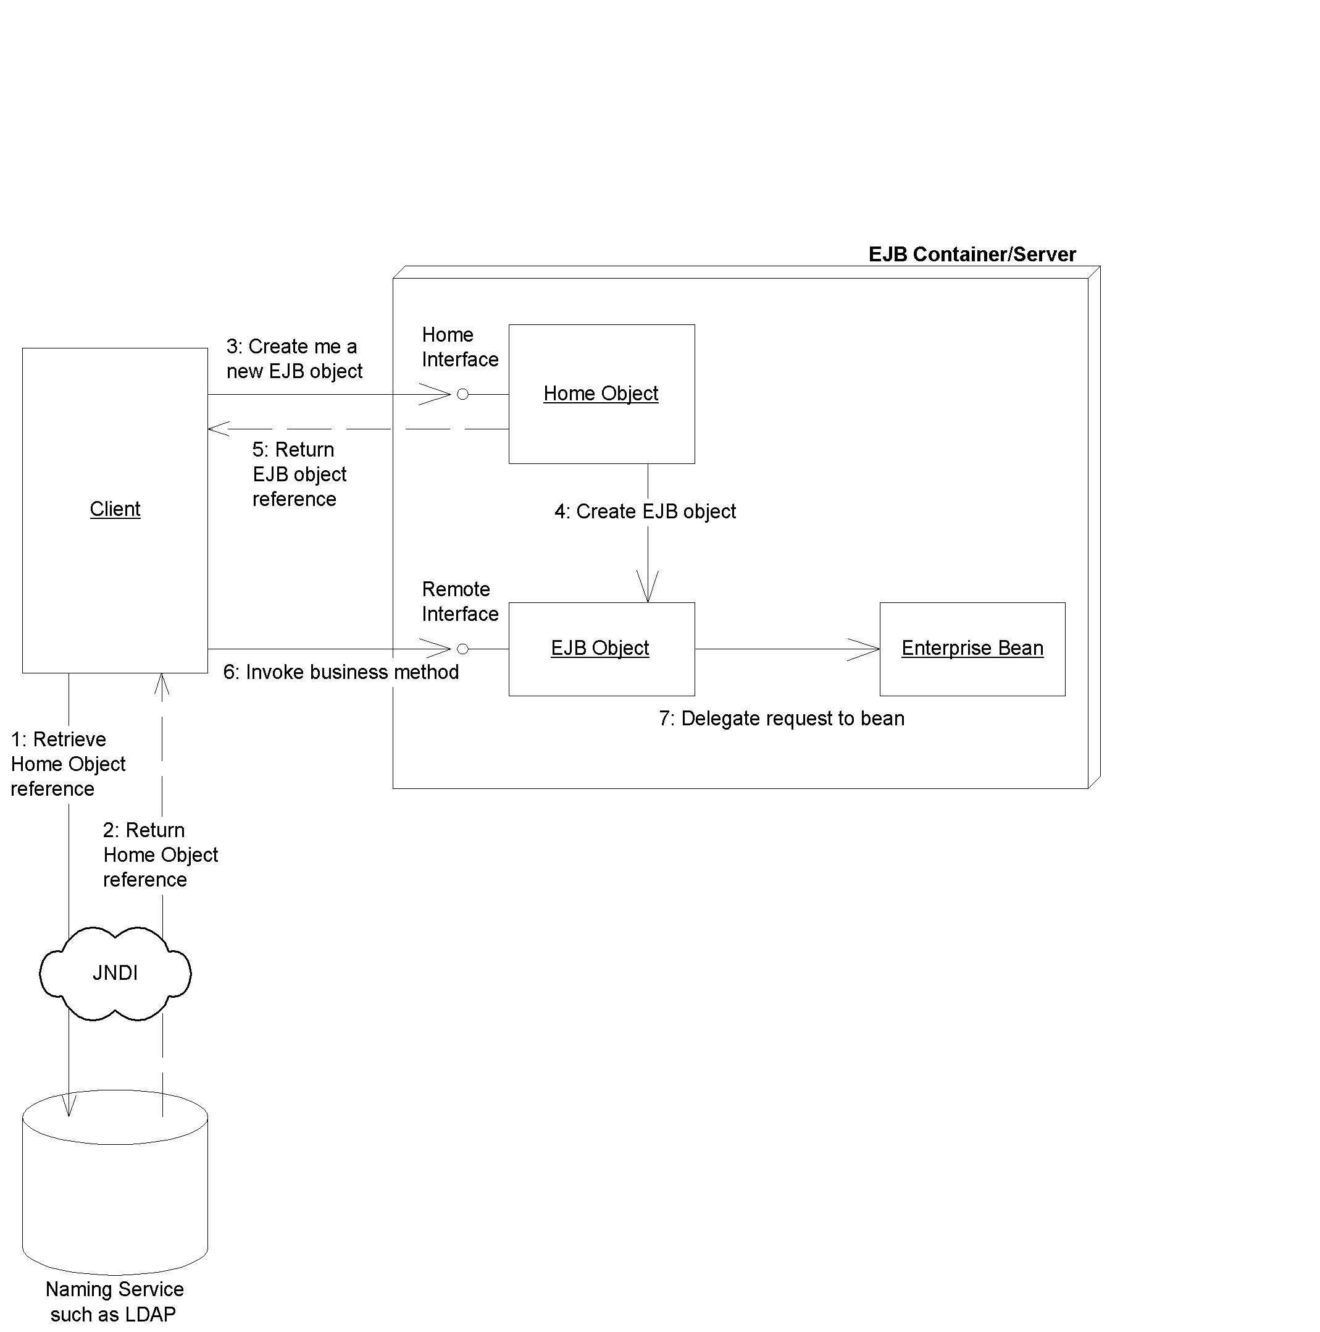Figure 2.X Acquiring a reference to a home object.
More concretely, your client code must execute the following steps to acquire a reference to a home object via JNDI:
Set up your environment. You must specify which directory service you’re using, specify the network location of the directory service you desire, and specify any usernames and passwords that may be required for authentication.
Form the initial context. The initial context is a local starting point for connecting to directory structures. You need to pass the initial context to the environment properties you just set up.
Retrieve the home object. To retrieve the home object, you must perform a JNDI lookup() operation on the remote directory. The returned object is an RMI remote object that you must cast to a home object.
The following code segment illustrates these steps:

/*
* Get System properties for JNDI initialization
*/
Properties props = System.getProperties();

/*
* Form an initial context
*/
Context ctx = new InitialContext(props);

/*
* Get a reference to the home object - the
* factory for EJB objects.
*
* CartHome is the remote interface type
*/
CartHome home = (CartHome) ctx.lookup("CartHome");
Creating an EJB Object
Once your client code has a reference to a home object, you can use that home object as a factory to create EJB objects. To create an EJB object, call one of the create() methods on the home. The following line illustrates this:

/*
* Cart is the remote interface type
*/
Cart ejbObject = home.create();
Calling a Method
Now that the bean’s client has an EJB object, it can start calling one or more of the methods that the bean exposes through the EJB object. When the client calls a method on the EJB object, the EJB object calls a bean instance. When the bean instance is done, the EJB object takes the return value from the bean’s method and ships it back to the bean’s client. This process is shown in Figure 2.X.
The following line illustrates calling an add() business method through the EJB object:
ejbObject.add("Laptop computer");
Destroying the EJB Object
Finally, when you want to destroy an EJB object, call a remove() method on the EJB object or home object. This enables the container to destroy the EJB object.
The following line illustrates removing our cart EJB object:
ejbObject.remove();
Summary
In this chapter, we’ve taken a whirlwind tour of Enterprise JavaBeans. We started by looking at what a bean is, and then the different kinds of beans, including session, entity, and message-driven beans.
We then took a bean apart into its constituent pieces, and examined each part: The enterprise bean class, the remote interface, the local interface, the EJB object, the local object, the home interface, the home object, the deployment descriptor, and the Ejb-Jar file.
Finally, we learned that you lookup a bean's home using JNDI, and we wrote some code that demonstrated how to call a bean.
The good news is that congratulations are in order--you’ve made it to the end of Part I! In these two chapters, you’ve taken the first steps necessary to understanding and mastering Enterprise JavaBeans. Now that you understand the high-level concepts, let’s move on and learn how to write and use each type of EJB component, starting with session beans.

